**Maison Alcée at the Grand Prix d'Horlogerie de Genève**

**The Grand Prix d’Horlogerie de Genève,**

**a prestigious event**

On Thursday, November 10, 2023, the Grand Prix d’Horlogerie de Genève ceremony took place at the Théâtre du Léman.

Established in 2001, the GPHG is often compared to the Oscars of watchmaking. This annual event celebrates and rewards excellence, creativity, and innovation in the art of timekeeping.

Each year, the jury is composed of international experts from the watchmaking sector. The selection of timepieces is meticulous, ranging from established Maisons to emerging young talents.

Laureates are distinguished not only by their beauty and design, but also by their technical prowess and innovation.

The creations of the laureates stand out not only for their beauty and design, but also for their technicality and innovation.

**Maison Alcée is rewarded with the Audacity Prize!**

The Maison received the Audacity prize with the Persée Azur timepiece in the 'mechanical clock' category.

Persée is not just a timepiece, it immerses you in space and time, transmitting knowledge of a mountainous territory inhabited by Franco-Swiss Jurassians. By assembling your own Persée timpiece, you will discover centuries-old craftsmanship, bringing the invisible: Time to life.

The Audacity Prize recognizes innovators who introduce new dynamics through innovative concepts and products.

Maison Alcée, honored with the prestigious Audacity Prize at the 2023 Grand Prix d’Horlogerie de Genève, stands alongside awardees such as Bulgari, Piaget, Audemars Piguet, and many others.

**The Bold Vision of Maison Alcée**

The Maison takes on the ambitious challenge of redefining the watchmaking experience by focusing on exceptional craftsmanship and high-end do-it-yourself. Its mission is to transmit the exceptional horological heritage to all those eager to discover its beauty and complexity.

**How did such an accomplishment come to fruition?**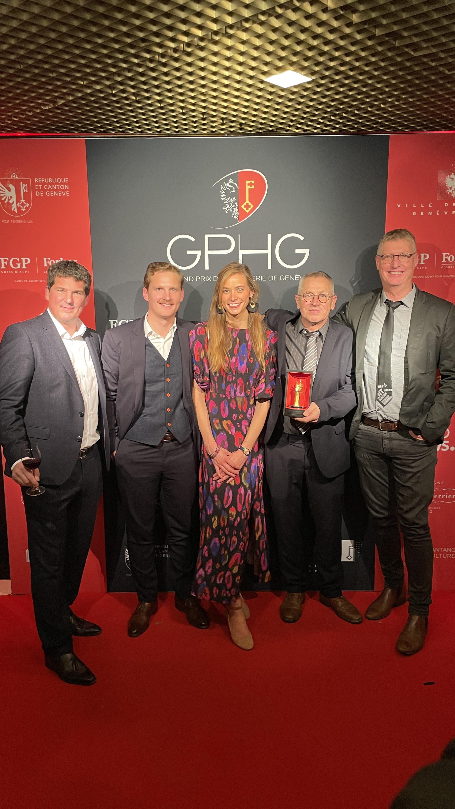

This feat was made possible thanks to the support of the select band of France’s ‘Best Craftsmen‘ (Meilleurs Ouvriers de France), Thierry Ducret, a swiss designer, Antoine Tschumi, and a professor in watchmaking construction, Jean-Marie Desgrange. Maison Alcée initiated an ambitious project: to offer everyone the opportunity to become the architect of their own time.

An exceptional case has been created, containing the 233 components of the timepiece in disassembled parts, as well as all the necessary watchmaking tools, some of which have been especially developed to facilitate their use for a novice.

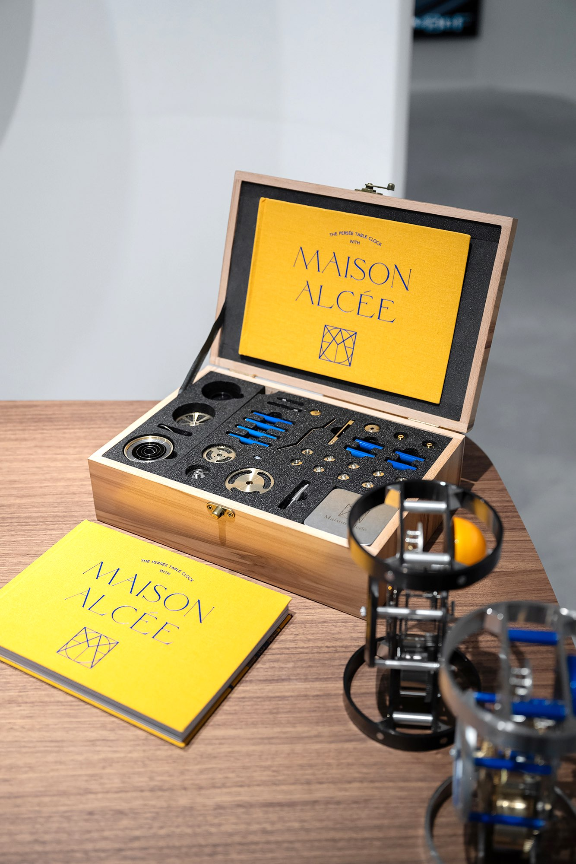

A beautiful book accompanies the set, guiding anyone eager to learn through the assembly of their own timepiece. The components come from french and swiss watchmaking excellence. The Maison works with around thirty local manufacturing partners, over 90% of which are located in the franco-swiss Jura region, which is quite rare.

Immerse yourself in the high-end do-it-yourself experience by assembling your timepiece with your own hands. An experience that awakens childhood memories. Every gesture evokes precious moments from the past, a nostalgic sweetness that makes every tick-tock of your timepiece even more valuable.

A risky challenge, but one that pays off as the Maison is repeatedly rewarded for its audacity.

**Press contact:**

Alcée MONTFORT

[contact@maison-alcee.com](mailto:contact@maison-alcee.com)

00 33 7 80 98 28 06

[www.maison-alcee.com](https://www.maison-alcee.com/en/)

To download the press pictures, please follow [this link](https://www.maison-alcee.com/en/images-presse/).

To watch Alcée's interview at the Grand Prix d'Horlogerie de Genève, please follow [this link](https://www.gphg.org/fr/videos/interview-de-alcee-montfort-maison-alcee).

To watch Alcée and Benoît's touching speech upon receiving the Prize of Audacity, please follow [this link](https://www.youtube.com/watch?v=kIFnM2jthSI).