Press Release - Audacity Talent
Paris, France - May, 28th 2024

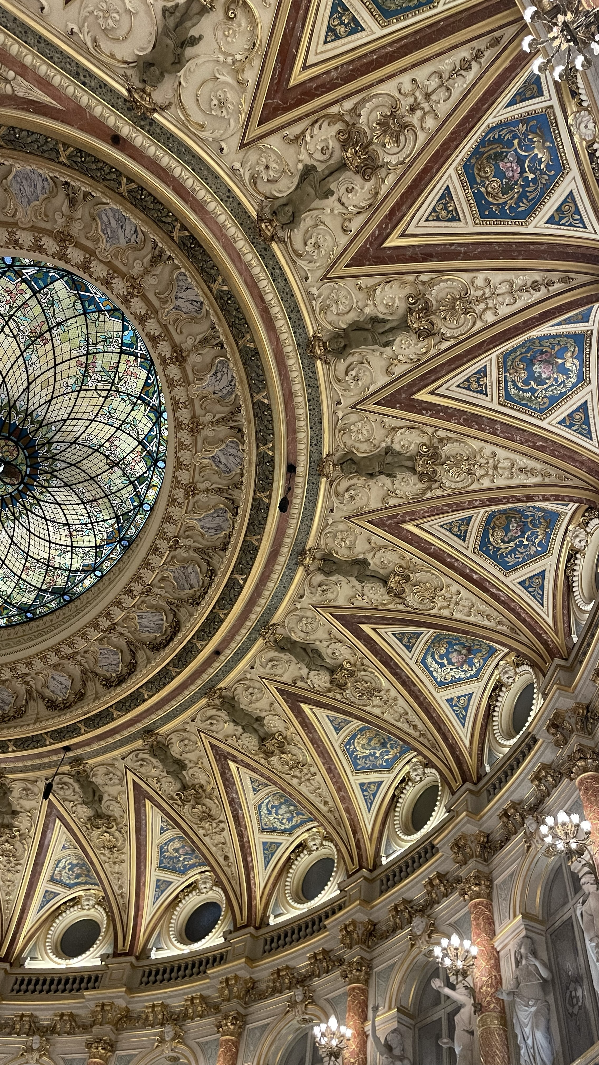
The recognition of luxury crafts

The Centre du Luxe et de la Création, a prestigious institution founded in Paris in 1978, is dedicated to promoting and preserving exceptional craftsmanship, from traditional artisanry to bold innovation. This institution supports young talents and emerging creators, thereby perpetuating the legacy of excellence in the luxury universe.
Each year, a jury composed of major personalities from the world of luxury awards 12 Talents to celebrate the 9 core values of luxury: Audacity, Well-being, Elegance, Harmony, Innovation, Invention, Originality, Rarity, and Seduction.
The Centre du Luxe et de la Création gathers the brightest minds and the most daring creators in various fields such as watchmaking, jewelry, perfumery, design, and many others.
This institution has recently highlighted undisputed figures of excellence such as Jean-Claude Biver, Maximilian Büsser, Cédric Grolet, and Karl Lagerfeld.
Here, talents are rewarded, and innovations are honored, celebrating excellence in a universe where every detail matters.
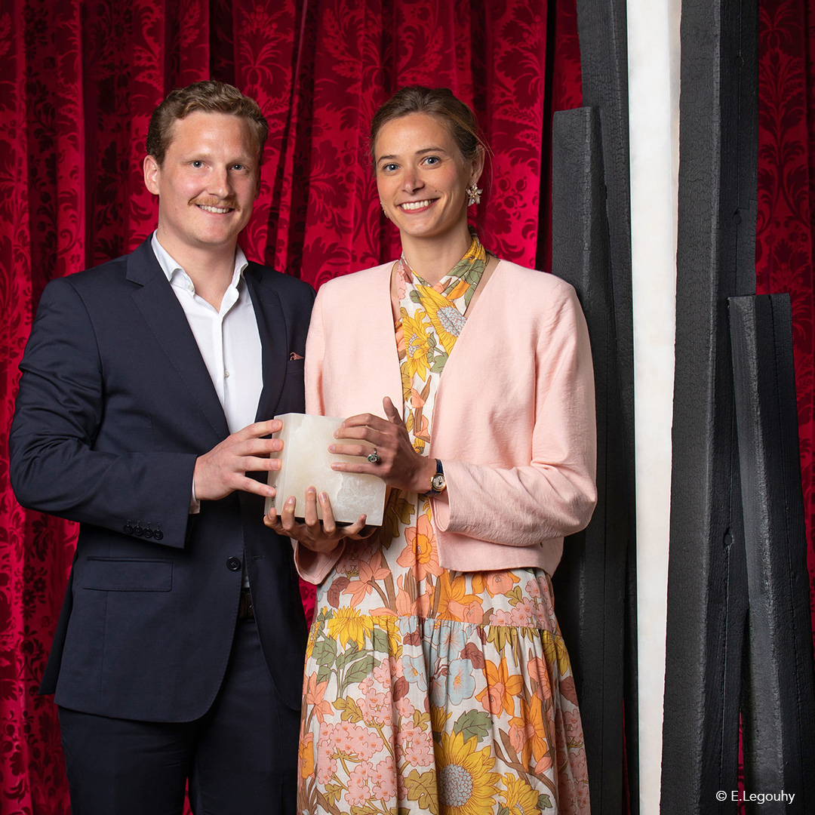
The Audacity Talent,
a prestigious award

The Audacity Talent is a distinction that highlights innovation and creativity in the luxury universe. This Talent aims to recognize individuals who propose innovative concepts and products, infusing a new dynamic.
Maison Alcée, honored with the prestigious Audacity Award at the Grand Prix d'Horlogerie de Genève in 2023, stands alongside other acclaimed Maisons such as Bulgari, Piaget, Audemars Piguet, and many more.

In 2024, the Maison is once again honored with the Audacity Talent, this time by the Centre du luxe et de la Création, and is proud of these two trophies.
This Talent rewards the Maison's bold watchmaking experience, thus encouraging the transmission of the franco-swiss watchmaking legacy worldwide.
The bold vision of Maison Alcée
The Maison has taken on the ambitious challenge of redefining the watchmaking experience by focusing on exceptional craftsmanship and high-end do-it-yourself. Its mission is to transmit the exceptional watchmaking heritage to all those who wish to discover its beauty and complexity.

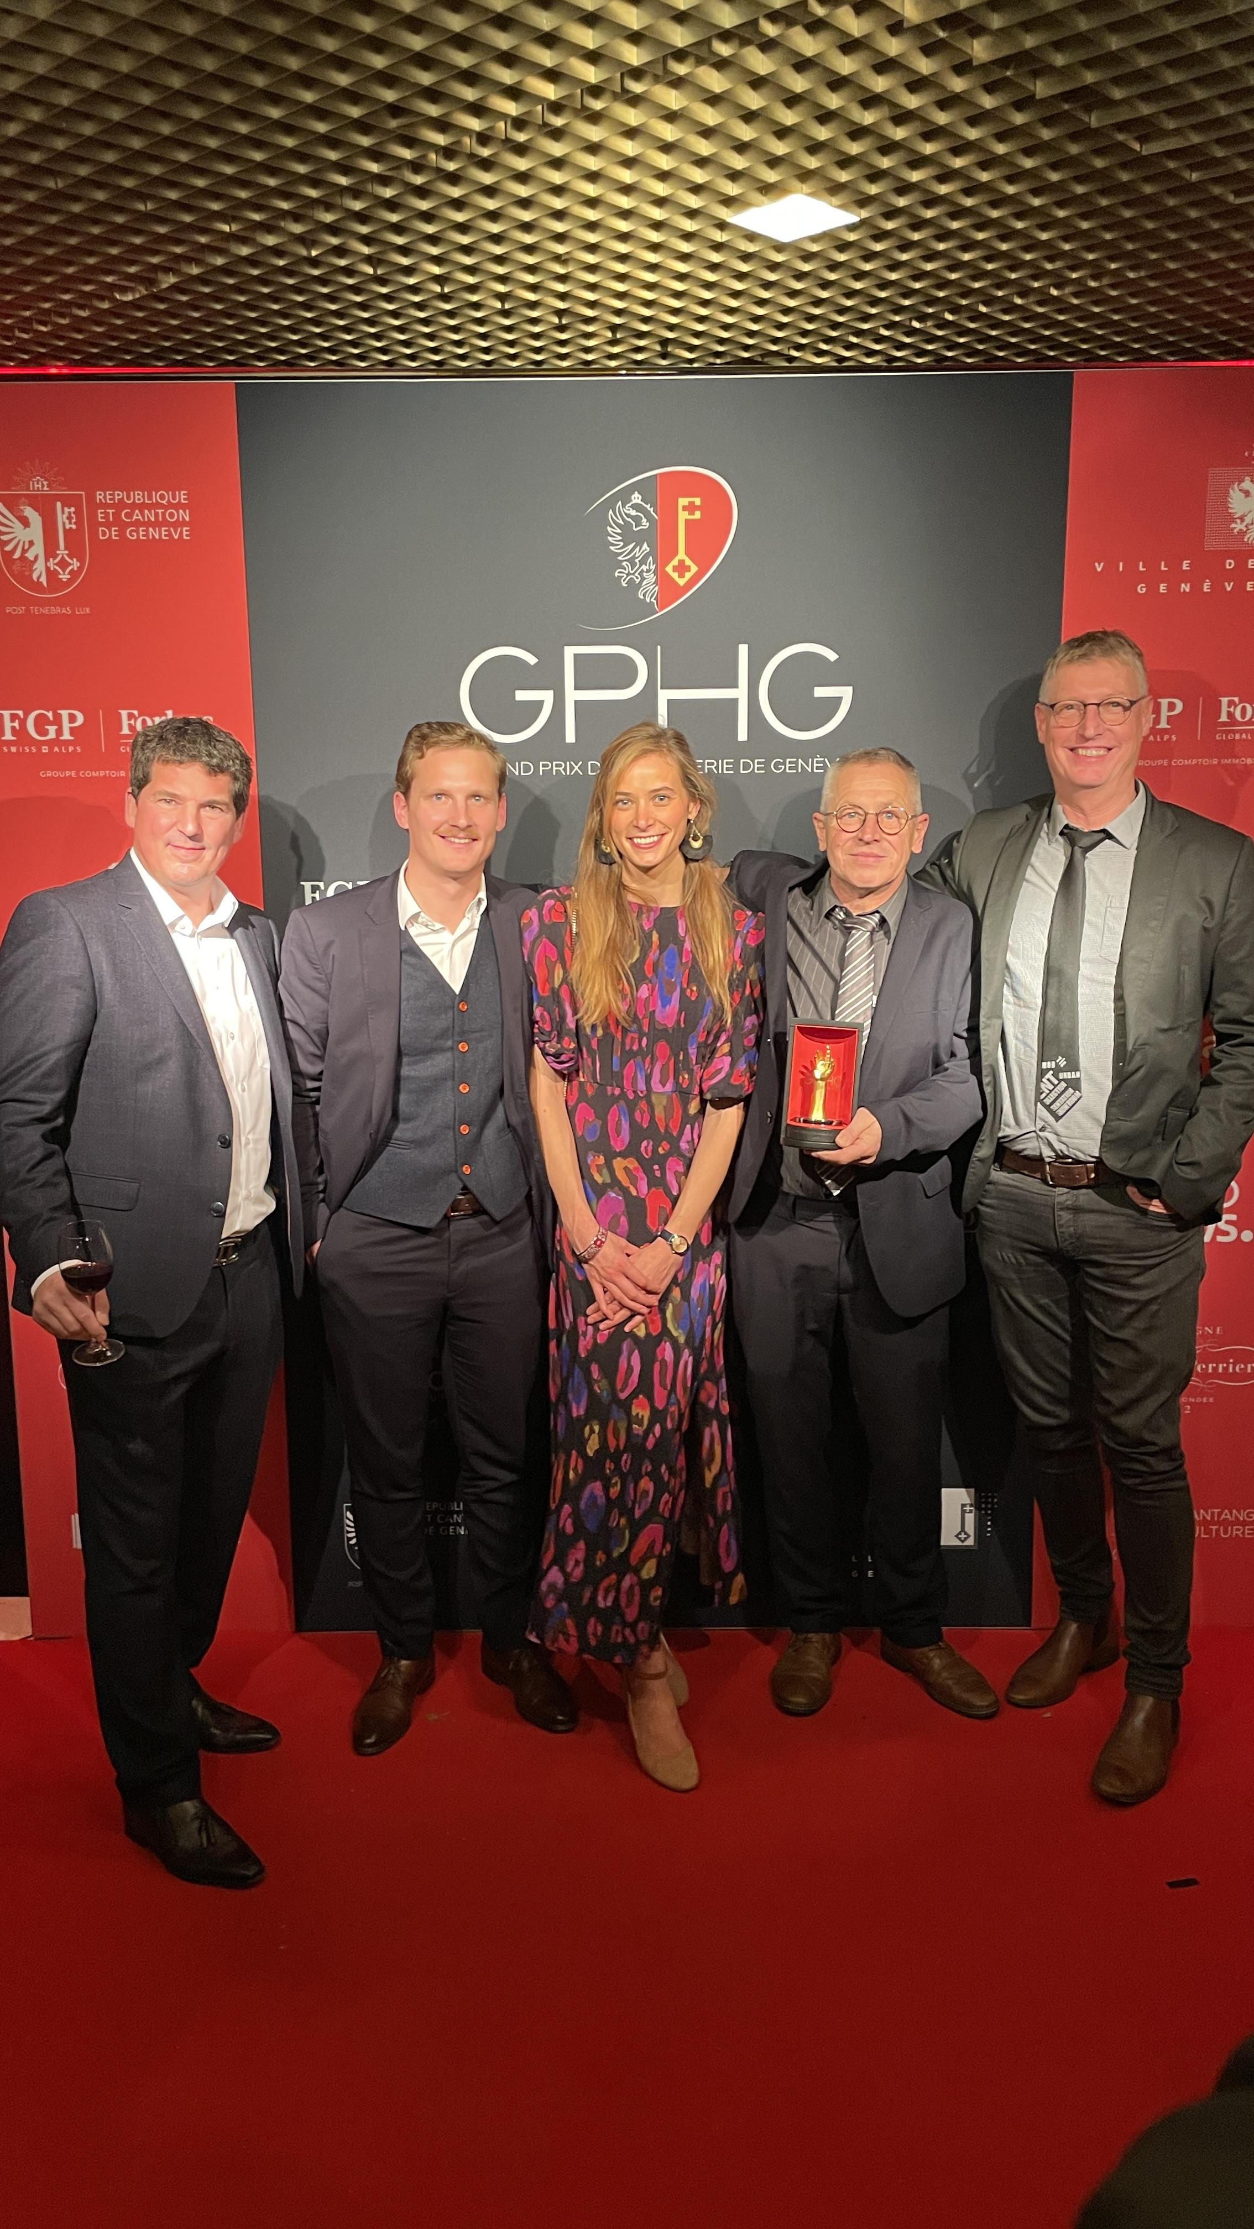
How did such an accomplishment come to fruition?
This feat was made possible thanks to the support of the select band of France’s ‘Best Craftsmen‘ (Meilleurs Ouvriers de France), Thierry Ducret, a swiss designer, Antoine Tschumi, and a professor in watchmaking construction, Jean-Marie Desgrange. Maison Alcée initiated an ambitious project: to offer everyone the opportunity to become the architect of their own time.
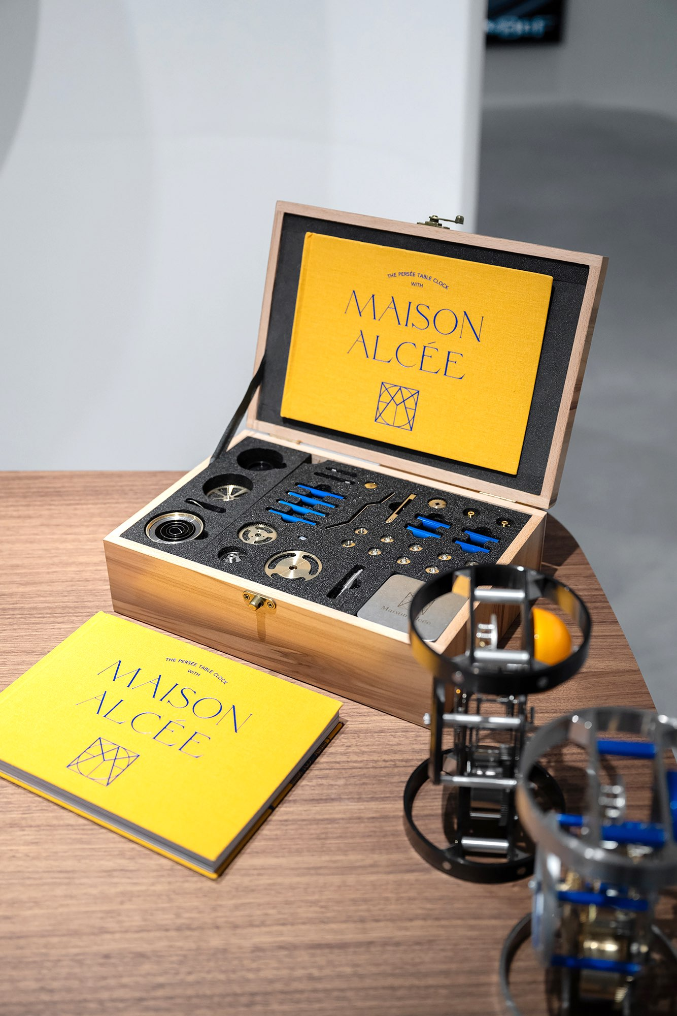
An exceptional boxset has been created, containing the 233 components of the timepiece in disassembled parts, as well as all the necessary watchmaking tools, some of which have been especially developed to facilitate their use for a novice. A beautiful book accompanies the set, guiding anyone eager to learn through the assembly of their own timepiece.

The components come from french and swiss watchmaking excellence. The Maison works with around thirty local manufacturing partners, over 90% of which are located in the franco-swiss Jura region, which is quite rare.
Immerse yourself in the high-end do-it-yourself experience by assembling your timepiece with your own hands. An experience that awakens childhood memories. Every gesture evokes precious moments from the past, a nostalgic sweetness that makes every tick-tock of your timepiece even more valuable.
A risky challenge, but one that pays off as the Maison is repeatedly rewarded for its audacity.

Press contact:

Alcée MONTFORT
contact@maison-alcee.com
00 33 7 80 98 28 06
www.maison-alcee.com

To download the press pictures, please follow this link.

