Maison Alcée at the M.A.D Gallery in Geneva
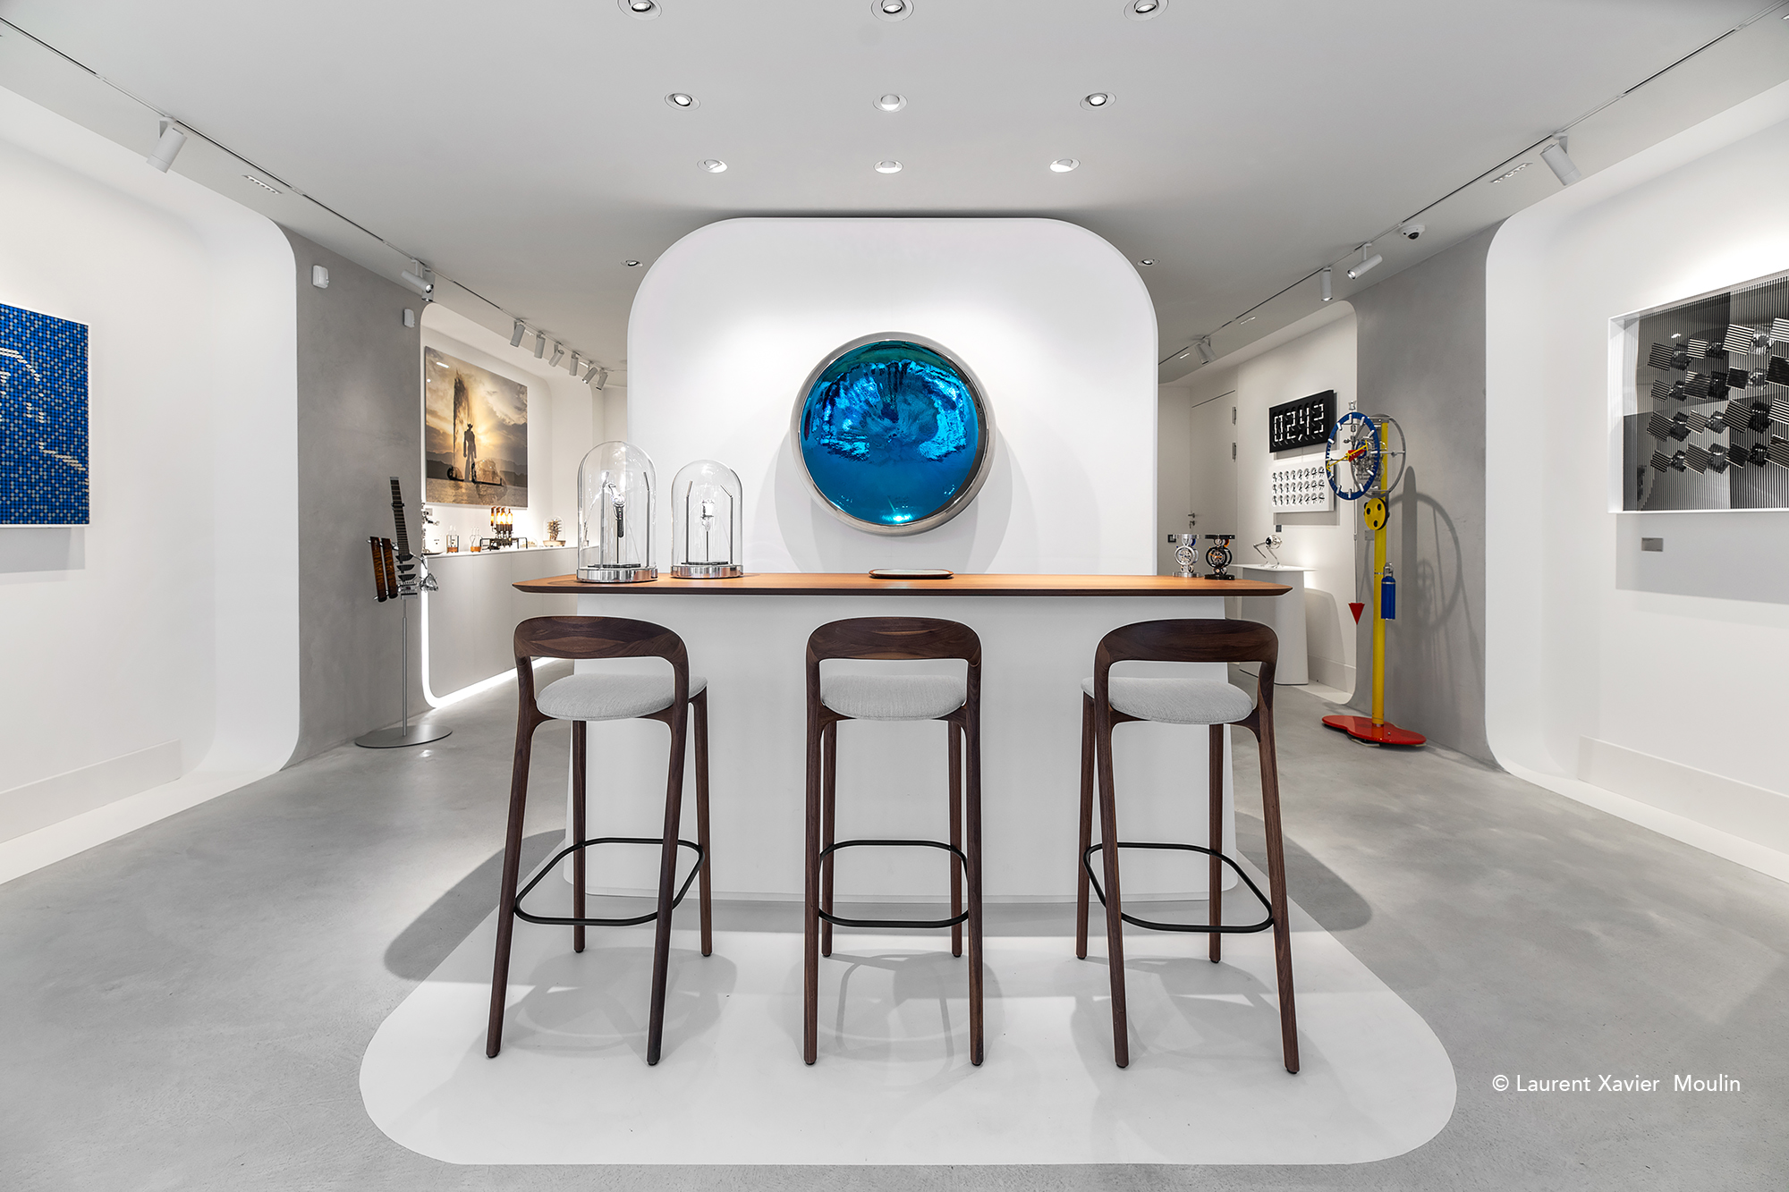
Geneva, Switzerland – April 8th 2024
Maison Alcée is proud to announce its presence at the prestigious M.A.D Gallery in Geneva, an initiative of MB&F, where the art of watchmaking meets creative expression.

Maison Alcée is much more than just a watchmaking Maison.

The story of Maison Alcée is a highly personal one that first began twenty-five years ago. When she was little, Alcée enjoyed creatively bringing materials to life – and promised herself she’d never grow out of it!

She has worked for several fine brands: Hermès, Cartier, and then in watchmaking for Richemont and Tag Heuer, where science and passion are seen as crucial to timekeeping in equal measure.

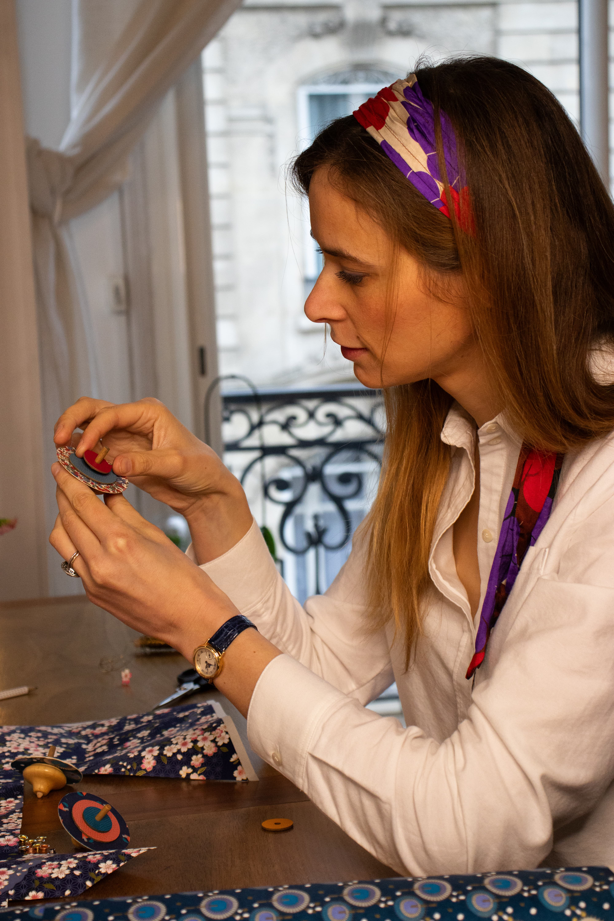
They were amazing years!

Alcée wanted to honor horology. It involves an almost philosophical approach to the mysterious and fascinating concept of time and requires a degree of scientific understanding that is not usually found in other manual craft.

This is how Maison Alcée's mission was born: to pass on the exceptional heritage of watchmaking to all those who wish to discover its beauty and complexity.

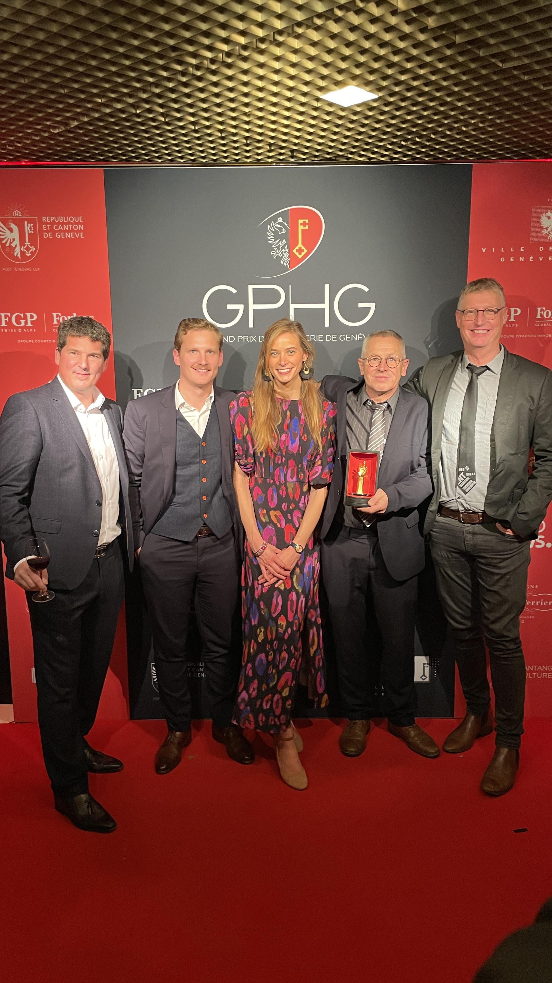
Maison Alcée has initiated
a bold project
Three years ago, with the support of her husband and several key people:
- Thierry Ducret, horology teacher and one of the select band of France’s ‘Best Craftsmen‘ (Meilleurs Ouvriers de France).
- Antoine Tschumi, a Swiss designer
- Jean-Marie Desgrange, a watchmaking teacher

Maison Alcée has started a bold project: to allow everyone to become the architect of their own time by assembling their own timepiece.

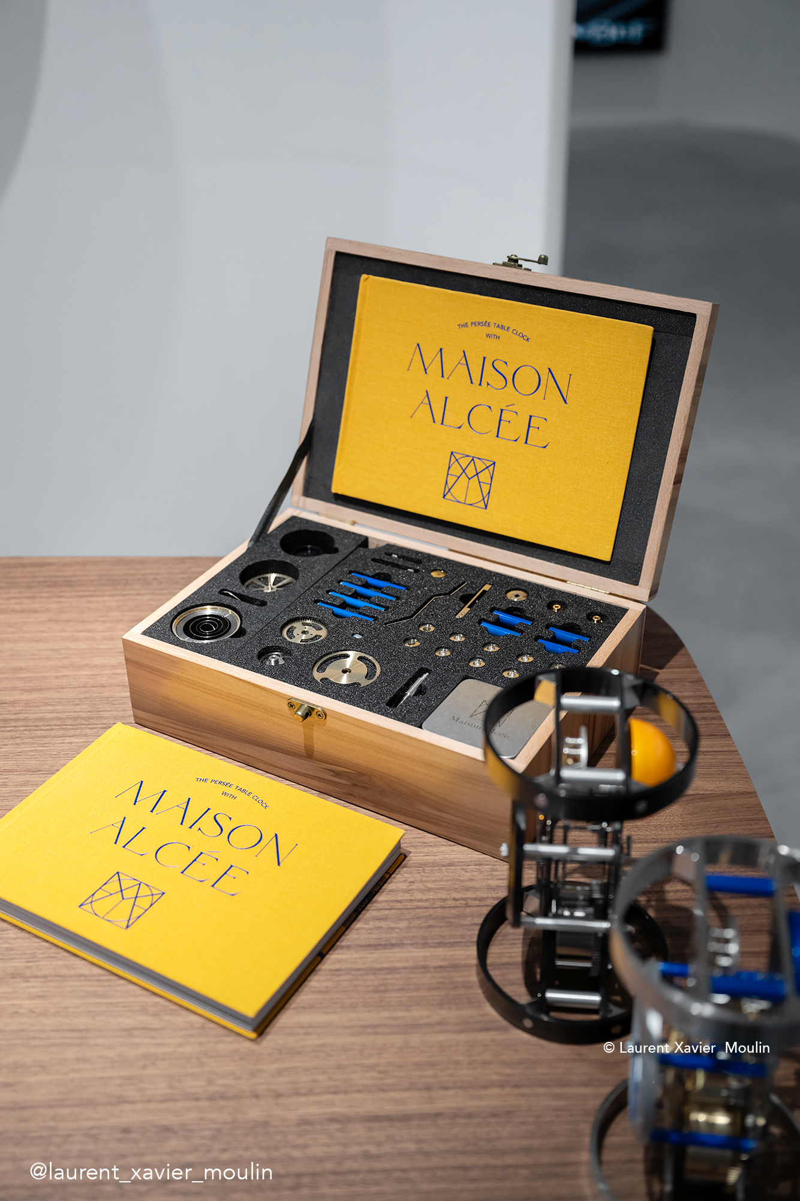
The result of this audacity?

Now, our ambition has come to fruition in the form of a presentation box containing all 233 parts of the timepiece, all the necessary tools (some of them especially developed to ensure they can be used by the uninitiated) and a beautiful book to accompany clockmaking apprentices on their journey to build a way of measuring time – perhaps even gaining an insight into time itself in the process.

Inveterate collectors, unrepentant enthusiasts and inquisitive newcomers alike can become heirs to ancient arts for a season – and in doing so, experience the pride of having made something with their own hands.

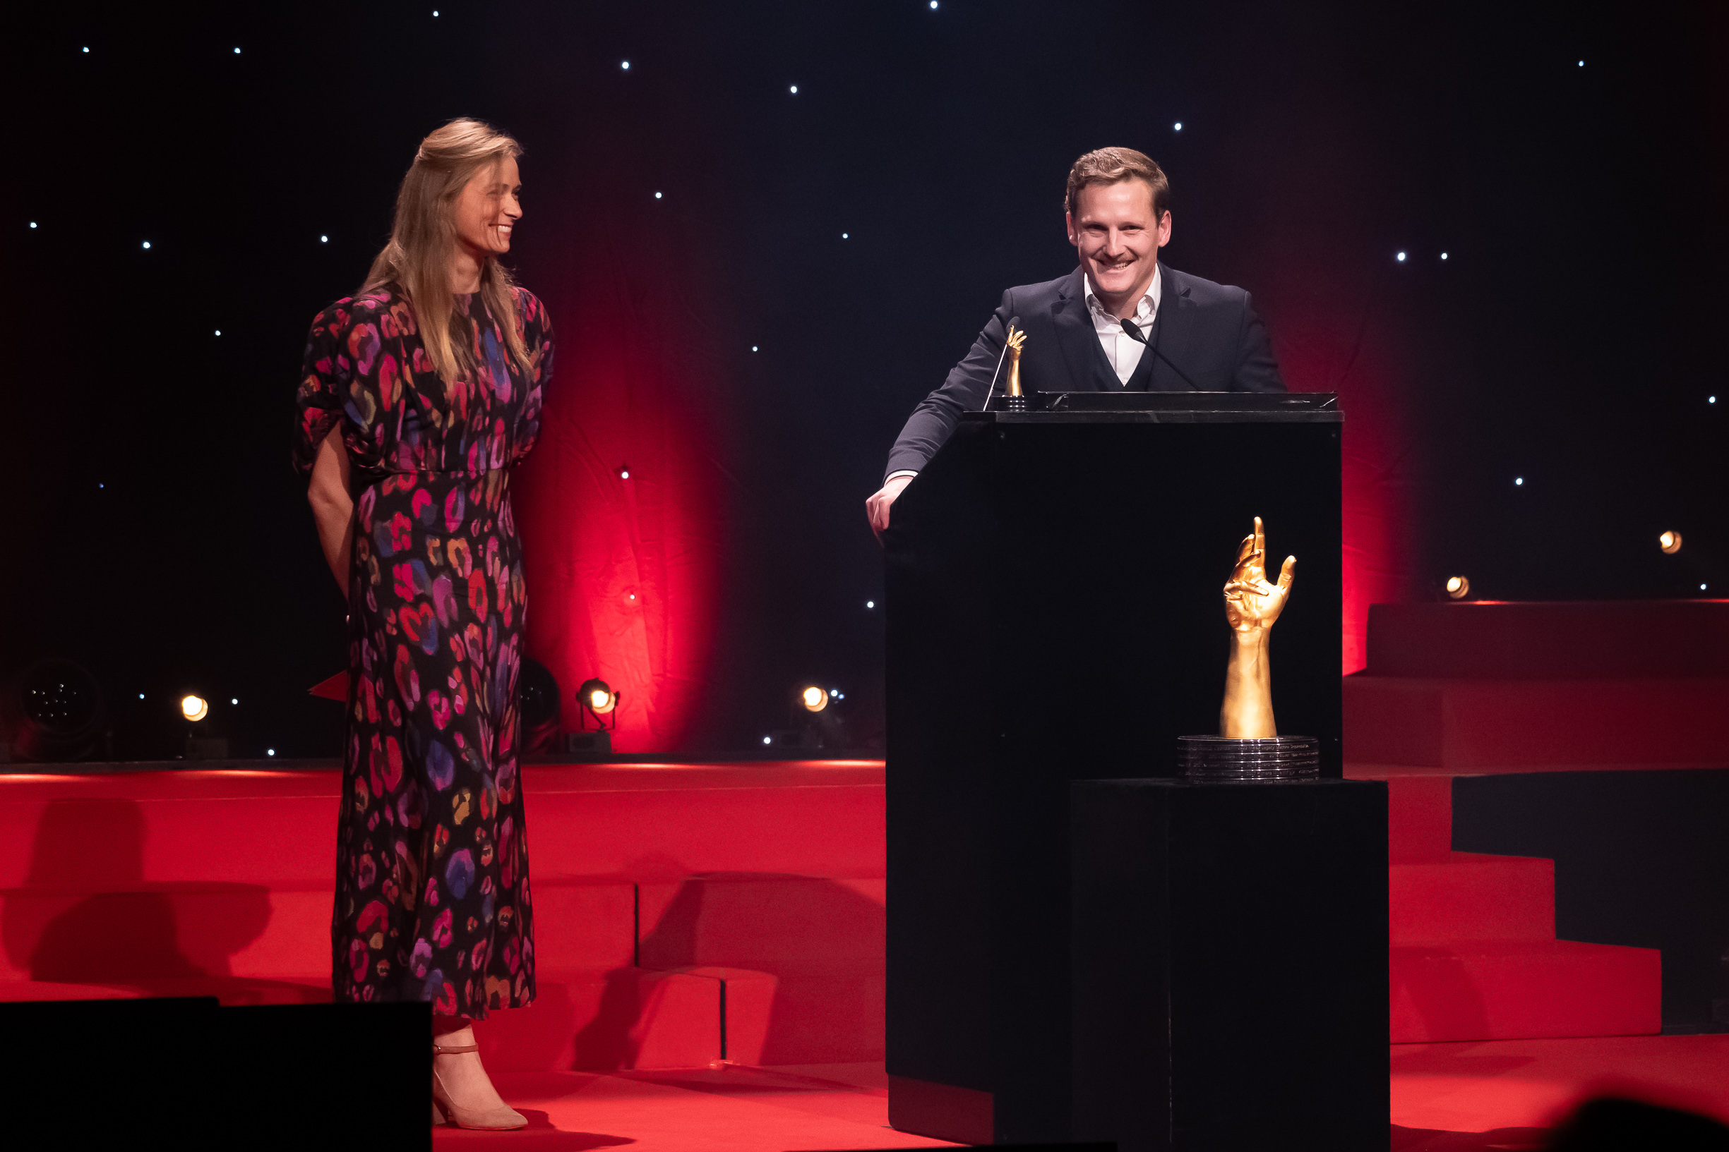
The Audacity Prize at the GPHG 2023
The Maison Alcée boxsets presented at the Geneva M.A.D Gallery were awarded the Audacity Prize at the Grand Prix d’Horlogerie de Genève in 2023.
This award is an honor for our young Maison. It highlights Maison Alcée's watchmaking experience with delicacy and passion.

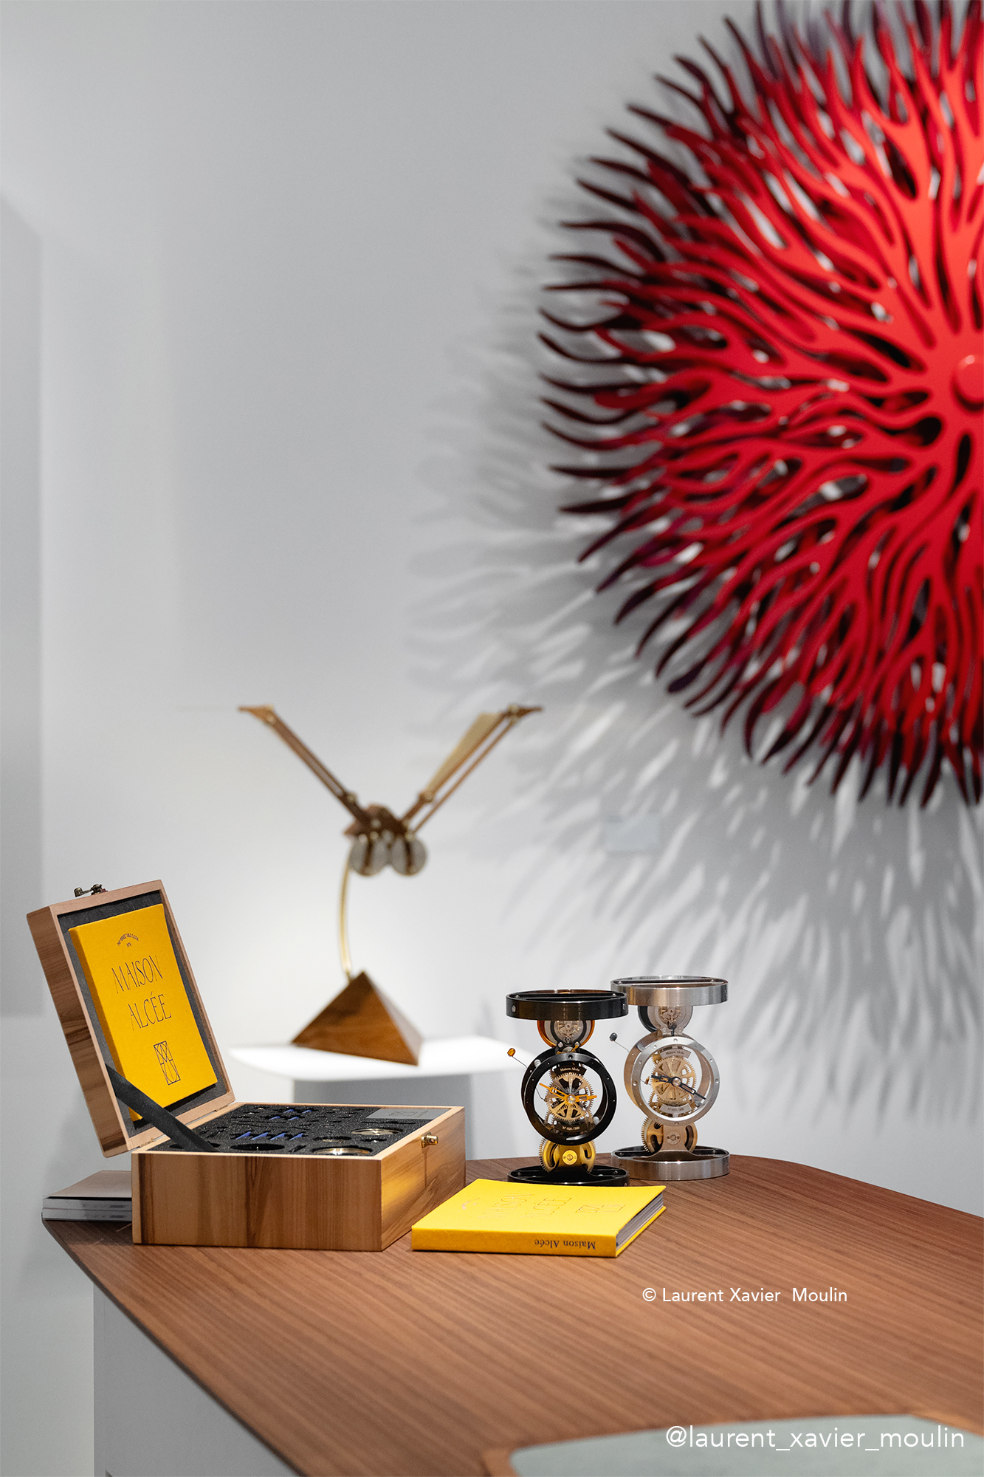
Maison Alcée joins forces with Geneva's M.A.D Gallery

A union where creativity, childhood and joy meet to offer a unique watchmaking experience.

We are honored to be part of the M.A.D Gallery family and to be accepted by the MB&F genius. We look forward to sharing this extraordinary adventure with all of you!

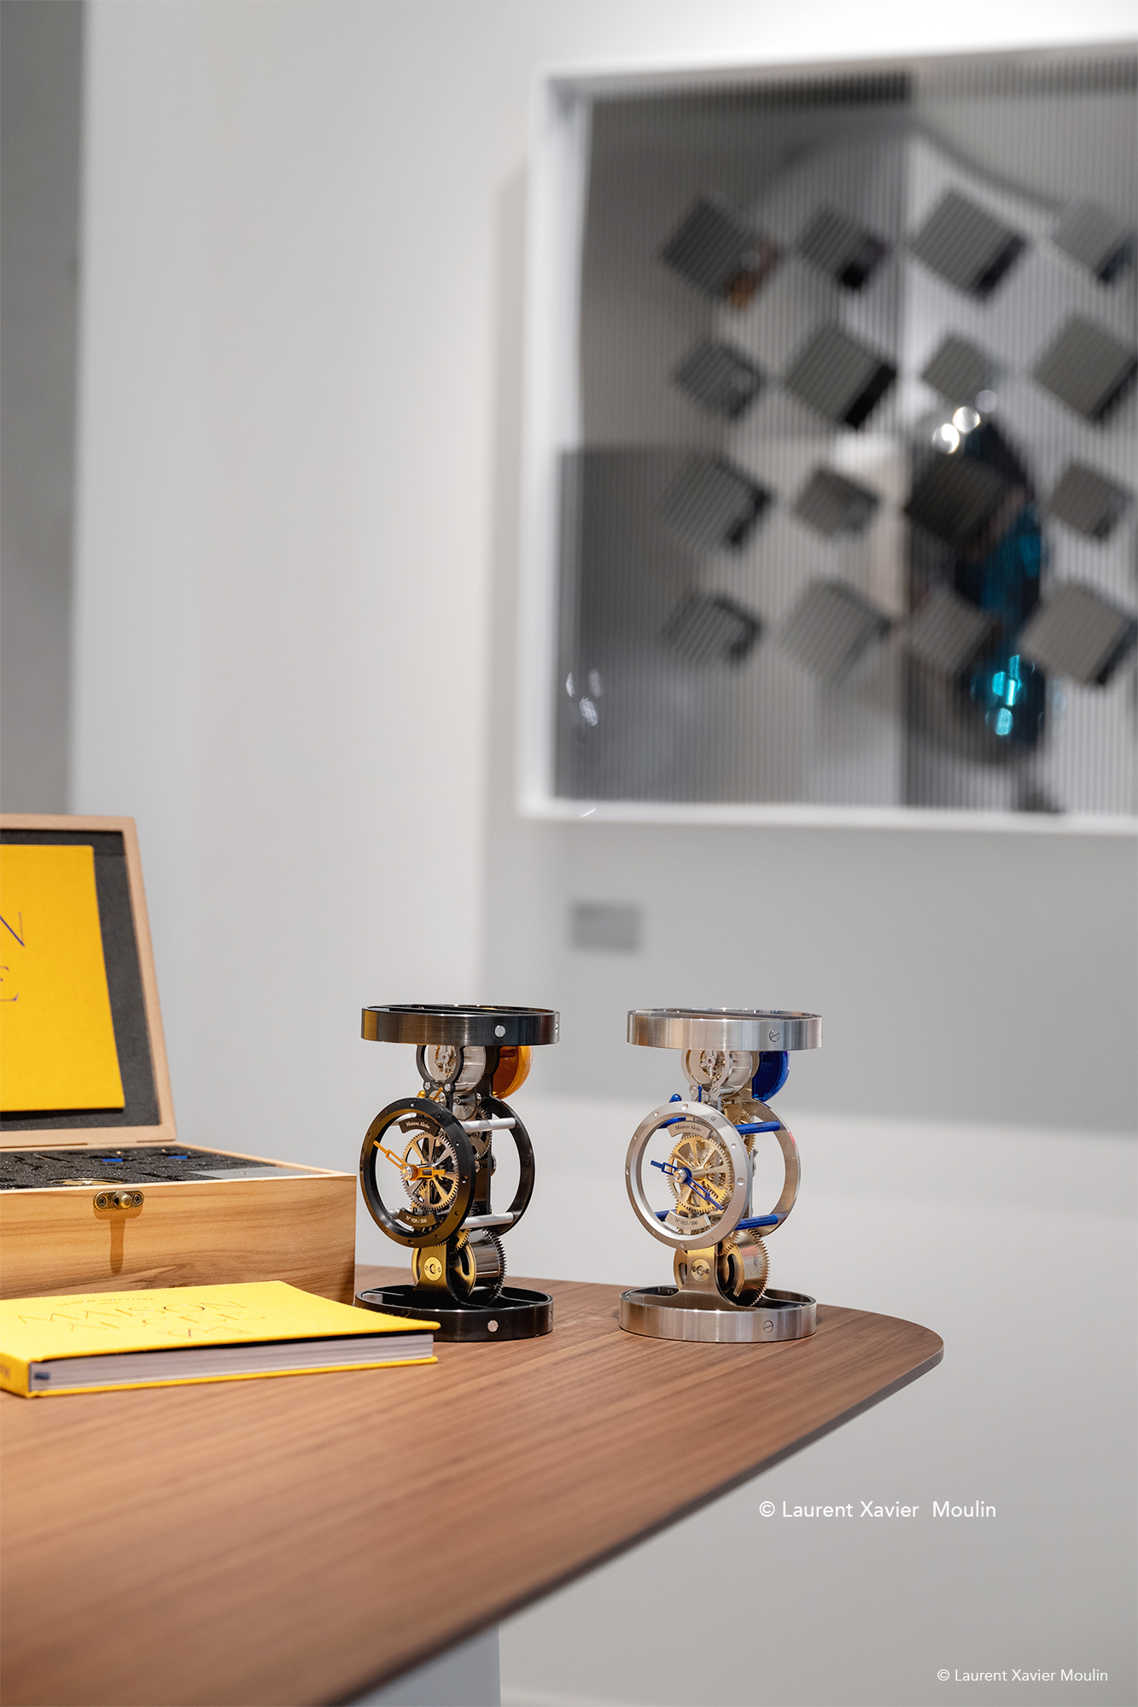
A unique watchmaking experience

This collaboration between Maison Alcée and Geneva's M.A.D Gallery promises an unprecedented watchmaking experience, where each watch becomes a story to tell, a moment to cherish, an emotion to share.

Join us in this adventure where time becomes a work of art, shaped by creativity and passion.

Press contact:

Alcée MONTFORT
contact@maison-alcee.com
00 33 7 80 98 28 06
www.maison-alcee.com

To download the press pictures, please follow this link.

